Below is the schematic of a two segment four-bar model, and the notation is defined in the schematic. I only have one-segment simulation done, therefore the effect from the upper segment is neglected .The MatLab code, which is poorly optimized and takes tens of seconds to run, can be found in this folder.

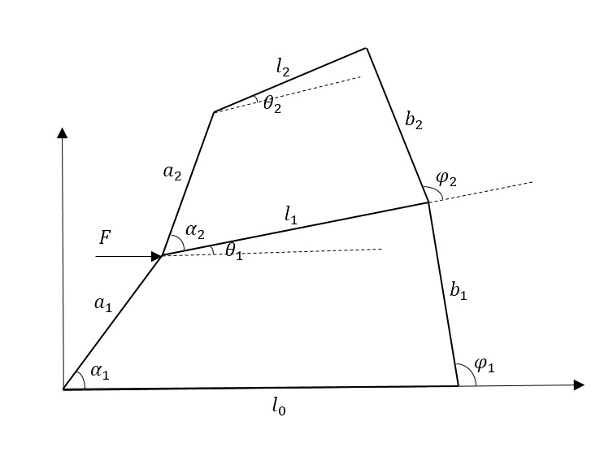

Below is a simulation result, for a 50 force applied. In the simulation all a1 = b1 = 1, l0 = 3, l1 = 2 and $K_{base}=180/pi$. The dash red line is the initial configuration and the solid blue line is the final configuration. At this configuration $θ_{1}=13.97° , α_{1}=29.89° and φ_{1}= 101.08°.$

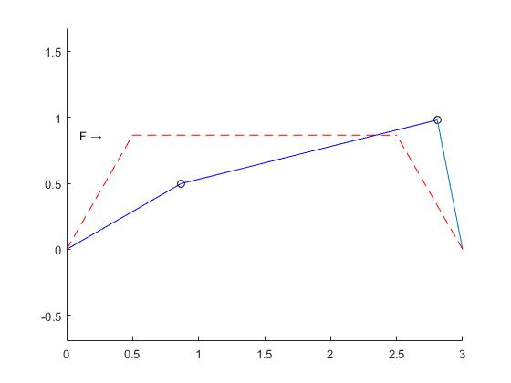

Below is the theta vs F curve.

